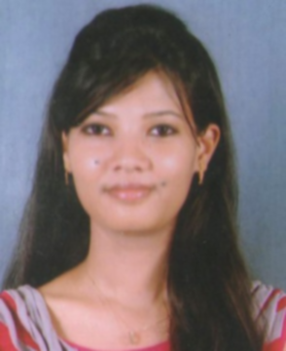**RESUME**

**Name:** Aditi Sinha

**Communication Address** C/o : SAMIR KUMAR SINHA

119, SRIMANIBAGAN, LICHUTALA, CHANDANNAGAR,

HOOGHLY – 712136.

**Contact No:** +919903500101

**Email Id:** sinha1040@gmail.com

**CAREER OBJECTIVE:** Seeking a management position with an organisation where I can utilise my skills to improve operations increase profitability and enhance growth.

**ACADEMIC QUALIFICATION:**

|  |  |  |  |
| --- | --- | --- | --- |
| INSTITUTE | NAME OF EXAMINATION | BOARD | PERCENTAGE |
| SKFGI  MANKUNDU | MBA  (MARKETING) | WBUT | 7.35 |
| BRB COLLEGE | GRADUATION  B.COM(H) | LNMU | 68 |
| SAINT KABIR COLLEGE | Higher Secondary  I.SC | BSEB | 72 |
| HOLLY MISSION HIGH SCHOOL | SECONDARY | CBSE | 73.25 |

## TRAINING

* Internship at EX-IN LTD. for two months.
* Workshop on stock market sponsored by NATIONAL STOCK EXCHANGE.

## EXPERIENCE

* Working as a Sales Executive from 2nd Feb 2015 onwards in The Pride Plaza

(Marketing Dept.).

## KEY SKILLS:

* Good communication
* Self confidence
* Leadership quality
* Planning and organising
* MS-Window XP, knowledge in MS-Word, MS-Excel, MS-Power Point, MS-Access.
* Cope up with the Technology.

## EXTRA-CURRICULAR ACTIVITIES:

* Won 2nd prize in debate at school level.
* Participated and won third position in the oral presentation at the 4th national conference (IC3-2014).
* Won several prizes in painting and singing at District level.
* Active participant in speech.
* Team leader in the school for a particular team.
* Diploma in Computer Application.

**PERSONAL DETAIL:**

|  |  |
| --- | --- |
| Date of Birth | 11/02/1991 |
| Father’s Name | Mr. Ashok Kumar Sinha |
| Domicile Address | C/o : SAMIR KUMAR SINHA  119, SRIMANIBAGAN, LICHUTALA, CHANDANNAGAR,  HOOGHLY – 712136. |
| Marital Status | Single/Unmarried |
| Language Known | English; Hindi. |

I hereby confirm that the information in document is accurate & true to the best of my knowledge.

Place: _______________________

Date: ________________________

Signature

(Aditi Sinha)